**PROJ 201 Project Final Report**

**Performances of Sectoral Indices in International Equity Markets**

Can Küçük 30415

Arda Aydın 29275

Ahmet Can Toksoy 30885

Behçet Batu Utku 30784

**Supervised by**: Doruk Günaydın

01.05.2023

**Abstract**

Evaluating the performance of investment indices is a crucial task for investors, as it allows them to make informed decisions about the allocation of their assets. In this article, we propose a framework for evaluating indices using a range of risk metrics, including Sharpe Ratio, Sortino Ratio, Value at Risk, and Maximum drawdown. Evaluating indices through the use of various formulas that would measure sectoral risk metrics. The evaluation of the data gathered will be collected and studied to observe which equity and industry of BIST performs better through the use of various risk metrics. EIKON terminal will be used to withdraw 20 years of daily data required for risk metrics and evaluated through calculations from excel.

Overall the study found that Sports, Telecommunication, Bank and Tourism performed worst generally in the metrics, while Basic Materials, Chemicals, Textile and National Technology performed better compared to the other. Study suggests that different sectors have different risks and these should be considered while creating an optimal portfolio. Also it can be mentioned that there is a correlation between performance of an industry in different risk metrics.

**Introduction**

There are quite a big number of equity markets, stakeholders and investors all around the world. An investor may decide to invest in an industry index. These indices may perform better or worse than each other in some periods according to their return or some other metrics (Robiyanto, 2017). These metrics include some risk metrics including Sharpe Ratio, Sortino Ratio, value-at-risk and Calmar Ratio. In different risk metrics equities and industries may be sorted differently according to their performances or in other words risk adjusted returns. This research aims to analyze different equities and industries in terms of different risk metrics to get information about how these equities and industries behaved in the past. Another purpose of this project is to evaluate the results of past data of different risk metrics to make a comparison between them. Moreover, it aims to stress the importance of the difference of risk metrics by showing the following: returns are not enough metrics by themselves. It is also important to understand the potential weaknesses of the measurements since it is extremely difficult to make perfect assumptions using particular metrics due to an abundance of uncertainties. “The Calmar ratio’s focus on drawdown means its view of risk is rather limited compared to other gauges, and it ignores general volatility” (Kenton, 2021).

The industries that are compared with each other perform differently in different risk metrics. As Simons (1998) asserted, there are different risk metrics which show different performance results. The reason for that is the different techniques that are used while assessing the risk in different measures. Moreover, it may be claimed that the result of metrics should have some coherence which is because these are all measuring some sort of deviation and return. Considering these, a study has been carried out about Sharpe Ratio, Sortino Ratio, Calmar Ratio and Value-at-Risk of Turkish equity market’s indices: BIST.

The importance of this investigation will determine the indices that performed better through the use of risk metrics stated previously. The performance of the indices as well as equities within certain industries will be evaluated and displayed on a table. Furthermore, an investigation will be carried out to evaluate the reason behind the indices' different return values from 4 measurements. Observations regarding, like-for-like return values of the equities and their respected correlation with one another will be evaluated through taking the average of measurement values. However, it is denoted that not all equities within an index share mutual public offering date. Hence the range of daily return index for an equity will be comparatively smaller for a firm that recently declared public offering compared to another equity that has been in an index for a longer period.

**Methods and Materials**

The financial data that will be used in the study will be taken from a database which is provided by the Sabancı University. The database that will be used is called Datastream/EIKON. To choose data and pick that data a specific computer in the Information Center will be used with reservation. The data will be taken in Excel files. In the data selecting stage 20 year range of daily BIST data used both to evaluate the equities and industries. While capturing the data due to a small error, ranges chosen are different from each other. While the whole range is equal, start and end dates shifted 10 weekdays. However, this should not create huge differences among each other.

This data will be presented according to different risk metrics called Sharpe Ratio, Sortino Ratio, Value at Risk, Calmar Ratio on Excel. Also while using these metrics rolling estimation, geometric mean return and different probability methods will be used. After the calculation of these risk metrics, results will be compared for equities and indices to make a meaningful analysis.

Sharpe Ratio: It measures the difference between the return and risk free rate and divides the result by standard deviation. Purpose of this is to compute the risk taken by the investor. The formula is = $\frac{R_{p} - R_{f}}{σ_{p}}$

Sortino Ratio: This ratio also works similar to Sharpe Ratio but it considers only the negative side of the interval. It measures the risk adjusted return as Sharpe. Also the formula of the Sortino is = $\frac{R_{p} - R_{f}}{semi-deviation}$

Return to Value at Risk: Value at risk refers to the possibility of dropdown for a given rate. Return to Value at risk also calculates the difference between return and risk free return to calculate the performance. The formula is = $\frac{R_{p} - R_{f}}{\left|VaR\right|}$

Calmar Method: Similar to above metrics Calmar also calculates a risk by first finding the difference between return and risk free return then divides it to Maximum Dropdown. Maximum Dropdown refers to the difference between the peak point and bottom point. The formula is = $\frac{R_{p} - R_{f}}{Maximum Dropdown}$

There might be slight miscalculations with our calculated ratios since we did not use a risk free rate when calculating them, we divided the average return of the indices by different values for each formula.

To make the above calculations, first standard deviation, minimum of a month, maximum of a month, semi deviation, average return, smallest and biggest return calculated using pivot tables in Excel. Then, ratios are found again using Excel’s pivot tables, then united in a Google sheets page. In the end each ratio sorted in itself. After these steps are finished a research is made in order to understand the reasons for the resulting order. News, government reports and articles are scanned and the inferences are made.

**Results**

**Part.1: Industries**

**Sharpe Ratio**

| **Industries** | **Sharpe Ratio** |
| --- | --- |
| TEXTILE | 0.07635 |
| INDUSTRIAL | 0.07553 |
| METAL GOODS & MACHINERY | 0.06642 |
| NON-METAL | 0.06536 |
| CHEMICALS | 0.06268 |
| NATIONAL TECHNOLOGY | 0.06145 |
| BASIC MATERIALS | 0.06078 |
| NATIONAL SERVICES | 0.05838 |
| TRANSPORT | 0.05637 |
| INSURANCE | 0.05364 |
| WOOD PAPER & PRINT | 0.05276 |
| LEASING | 0.05037 |
| FOOD & BEVERAGE | 0.05036 |
| RETAIL & TRADE | 0.04997 |
| NATIONAL FINANCIAL | 0.04882 |
| INFORMATION TECHNOLOGY | 0.04874 |
| INVESTMENT TRUST | 0.04808 |
| HOLDING | 0.047885 |
| ELECTRICITY | 0.047876 |
| TOURISM | 0.04576 |
| BANK | 0.04041 |
| SPOR | 0.02582 |
| TELECOMMUNICATION | 0.02339 |

(Table 1.1: Sharpe Ratios of Industries)

To acquire the above table Sharpe ratios of the given sectors are calculated using their Price Index. In this calculation dividend is not included. Then industries sorted in terms of their Sharpe Ratios. According to their Sharpe Ratios, the most successful ones are Textile, Metal Goods, Chemicals, Non-Metal and National Tech. According to their Sharpe Ratios; the worst ones are Electricity, Tourism, Bank, Sports and Telecom.

The reason for the Telecom industry to be the one of the worst is the following: One of the biggest equity in this industry has changed hands multiple times in the period that we collected data. Türk Telekom had big amounts of debts and was bought back by the Turkish Wealth Fund. There are lots of rumors related to Türk Telekom (Yeniçağ, 2021). Also Sports has one the worst Sharpe Ratios which is similar to the Telecom. The reason for that is in the nature of the Sports equities. Because buying equities is similar to gambling their risk adjusted returns were expected to be low. Although it is suggested that it is a good time to invest in global sports industries (Wang, 2021), Turkish Sports index has its own risks. As it can be seen, all four clubs that are included in the Turkish Sports index have great debt (TrtSpor, 2022), which makes the sector vulnerable. Also Turkish Banking sector coped with big risks in the mentioned period of time due to the Halkbank crisis (Kose, 2021). It can be claimed that risks of the sector increased or returns reduced.

On the other hand, Textile industry had a very good Sharpe ratio compared to others. It has a 14.95% better ratio than its second closest opponent. Textile industry of Turkey is highly supported by the government. In most of the provinces industry has exemptions on KDV, tariff and other taxes (Plus Global Danışmanlık, 2020). This sector also has lots of monetary support in incentive provinces (Plus Global Danışmanlık, 2020). Furthermore, because of their comparative cost advantages, developing countries have massive shares in the worldwide textile industry (Tandon & Reddy, 2013) as shown in the figure (Figure 1.1). Another sector that has a quite positive Sharpe Ratio is Metal Goods. This sector also has government support. Companies such as Ford Otosan (Yeşil Ekonomi, 2020), Vestel (Hürriyet, 2018), Anadolu Isuzu (Foreks, 2022), Karsan (uzmanpara.milliyet.com.tr, 2021) and other companies have been given millions of Turkish Lira incentives every year. Similar to textile, the global motor vehicle assembly sector is highly encouraged in developing countries and the Turkish government fits in this trend (Residency of the Republic of Türkiye Investment Office, 2021) as shown in the figure (Figure 1.2). The Chemical sector also constitutes some of the biggest companies of Turkey such as Tüpraş and Petkim. This industry has had an important growth since the 1970s (Republic of Turkey Ministry of Trade, 2022).

An important point is the following: Top 3 industries according to the Sharpe Ratio are nested with each other. These are raising together due to their supply chain needs. As the report of the Ministry of Trade (2022) shows “Today, the Turkish chemical industry with its modern technology and diversified products is the key component of the industry and integrated into the supply chain of national industries, especially, textiles and automotive sectors.” Another remarkable element is that these industries are the major industries that Turkey is relying on for its export (Republic of Turkey Ministry of Trade, 2022).

As expected non-metal industry or in other words stone and soil industry has a good Sharpe Ratio. The reason why it is expected is that this sector consists mostly of cement companies which have quite tied with the construction sector. Even though construction and real estate are not calculated in this list; due to support and incentive packages, growth of these sectors should positively correlate with non-metal industry. Hence, the growth model of Turkey is referred to as ‘construction based growth’ (Bayrak & Telatar, 2021, 1284). This situation demonstrates the reason for growth in this sector.

Regarding the overall situation of the table, following can be said, sectors which were not encountered with big crashes and promoted by the government itself seem better in terms of their risk adjusted returns. The sectors that contribute to the financing of the current deficit are highly encouraged in this 20 year period which makes them less risky and more profitable. The sectors which are encountered with debt problems (sports, telecom) seem riskier or less profitable.

|  |  |
| --- | --- |
|  |  |

(Figure 1.1: 2019 Textile Output in the Global Share)

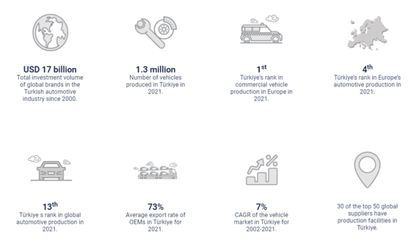

(Figure 1.2: Automotive Sector of Turkey)

**Sortino Ratio**

| **Industries** | **Sortino Ratio** |
| --- | --- |
| NON-METAL | 0.05067 |
| TEXTILE | 0.05015 |
| INDUSTRIAL | 0.04782 |
| INFORMATION TECHNOLOGY | 0.04716 |
| TRANSPORT | 0.04604 |
| METAL GOODS & MACHINERY | 0.04358 |
| NATIONAL TECHNOLOGY | 0.04305 |
| INSURANCE | 0.04291 |
| NATIONAL SERVICES | 0.04262 |
| BASIC MATERIALS | 0.04160 |
| CHEMICALS | 0.04144 |
| LEASING | 0.04039 |
| WOOD PAPER & PRINT | 0.03972 |
| ELECTRICITY | 0.03924 |
| TOURISM | 0.03878 |
| FOOD & BEVERAGE | 0.03854 |
| RETAIL & TRADE | 0.03837 |
| INVESTMENT TRUST | 0.03826 |
| NATIONAL FINANCIAL | 0.03625 |
| HOLDING | 0.03460 |
| BANK | 0.03297 |
| SPORTS | 0.03065 |
| TELECOMMUNICATION | 0.02417 |

(Table 1.2: Sortino Ratios of Industries )

The Sortino Ratio of the industries given in the table were calculated by taking the dividend adjusted price indices of the industries and dividing it with their semi deviation. The Sortino ratio is very similar to the Sharpe ratio which was analyzed earlier, however unlike the Sharpe ratio which considers the standard deviation deviation of both the upside and the downside risk, the Sortino ratio only considers the standard deviation of the downside risk, which is the semi deviation we used in the formula. A higher Sortino ratio means that the industry yields higher returns per unit of downside risk so it is better to invest in industries with higher Sortino ratios.

The bottom end of the Sharpe ratio and Sortino ratio tables are quite similar with each other and as with the Sharpe ratio table, the worst three performers on the Sortino ratio table were Telecom, Sports and Bank respectively. Some differences in rankings can be observed as we move higher up in the table. The reason for these differences are caused by a higher downside risk factor compared to upside risk. The best three performers on the Sortino ratio table were Non-Metal, Textile and Industrial.

The reason why Non-Metal and Textile industries perform well is government aid provided to these industries. The textile sector is granted exemptions to some taxes and is given different amounts of monetary aid based on the region of the firm. (Plus Global Danışmanlık, 2020). The reason why the Non-Metal industry performs well is because of government aids in the past (Özel İhtisas Komisyonu, 2008) (Figure 1) to stimulate and strengthen the industry since it is a very important industry and is also closely tied in with the construction industry, which is one of the leading industries in Turkey.

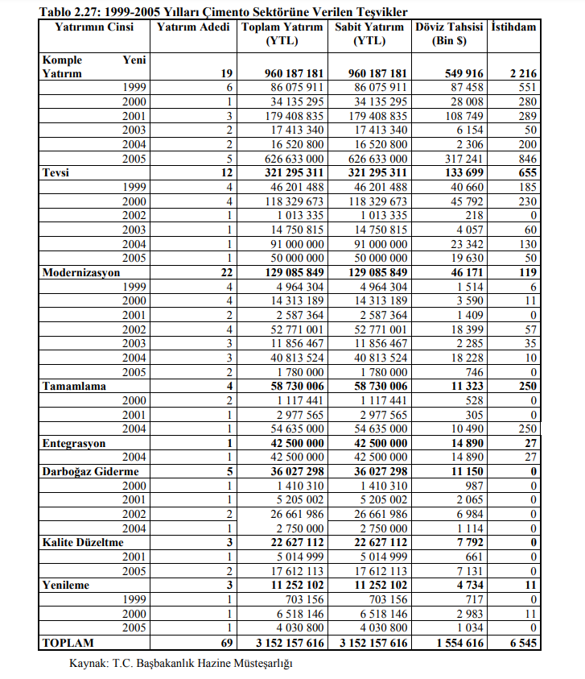

(Figure 2.1:Özel İhtisas Komisyonu, 2008)

One of the major reasons why the Telecommunication industry performs so poorly is because one of the biggest players in the telecom industry, Türk Telekom, accumulating lots of debt and changing ownership quite a few times caused the price index of the Telecom industry to decrease and fluctuate quite often and which caused a decrease in the average returns and an increase in the downside risk of the industry, especially in 2018.

The reason why the Sports industry performs poorly is because of the risks associated with the industry. Most of the firms in the Sports industry of Turkey are in debt and this may cause uncertainty and instability in the price index of the industry, causing low returns and high downside risks. The industry also faces risks with investments since if the investment isn’t profitable for some time, the firms might have a hard time maintaining their financial health and might have to leave the market. (Wang, 2021)

Finally, the reason why the banking industry performs poorly is because of the debt the banks in Turkey accumulate and the unstable nature of the price indexes such as the index of banks plummeting after 2013, and a recent lawsuit regarding one of the biggest banks in Turkey, Halkbank.

By looking at the table, it can be concluded that investing in Non-Metal, Textile and Transport is quite safer and they have more returns per unit of risk while investing in Sports, Banks and Telecom is risky since they have lower returns per unit of risk.

**Return to Value at Risk**

| **Industries** | **Return to Value at Risk** |
| --- | --- |
| LEASING | 0.23243 |
| NON-METAL | 0.06989 |
| TEXTILE | 0.06954 |
| TRANSPORT | 0.06412 |
| INDUSTRIAL | 0.06318 |
| INFORMATION TECHNOLOGY | 0.06148 |
| NATIONAL TECHNOLOGY | 0.05966 |
| CHEMICALS | 0.05955 |
| NATIONAL SERVICES | 0.05826 |
| INSURANCE | 0.05811 |
| BASIC MATERIALS | 0.05683 |
| METAL GOODS & MACHINERY | 0.05641 |
| ELECTRICITY | 0.05616 |
| FOOD & BEVERAGE | 0.05575 |
| WOOD PAPER & PRINT | 0.05440 |
| RETAIL & TRADE | 0.05434 |
| INVESTMENT TRUST | 0.05369 |
| TOURISM | 0.05294 |
| NATIONAL FINANCIAL | 0.04891 |
| BANK | 0.04554 |
| HOLDING | 0.04395 |
| SPORTS | 0.04039 |
| TELECOMMUNICATION | 0.03564 |

(Table 1.3: Average Return to Value at Risk of Industries)

The table above shows the sorted average Return to Value at Risk Ratio of industries from largest to smallest. To acquire the table, the formula $\frac{R_{p} - R_{f}}{\left|VaR\right|}$ is applied using the price indexes of the industries. Here, VaR is a method to calculate the possible maximum losses in a given period of time. The goal of Return to Value at Risk is to show the average return per collapse risk. It can be interpreted as the best average return compared to the number of bad days in a period of time. Higher Return to VaR can be achieved in conditions such as high return after collapses, or relatively low collapses and low average return in a period.

According to the table, the highest ratio belongs to the Leasing industry which has a significant difference from other ratios. This might have occurred because of a possible error calculating return since the leasing sector stands around mid-table in other three ratios. In this respect the average ratio is probably unrealistic and incorrect.This is followed by the Non-Metal, Textile, Transport, and Infotech industries. The rest of the ratios follow close to each other with Bank, Holding, and Sports slightly falling behind. Adversely Telecom has the smallest Return to VaR value.

Despite the calculating error, possible reasons for leasing to have a high ratio might be because of the structure of the business. Since financial leasing companies make contracts that last for a long amount of time; during a collapse, it might continue to supply the same business and have a sustainable business record. Considering leasing being closely interacted with economical activity, the number of bad days might increase as the Turkish economy fails since there will be less demand for leasing. Which would possibly result in a high number of negative days although having high returns. Also, the leasing industry has government incentives where the government only takes 1% value-added tax allowing better profits opportunities and attraction (Şişman, 2017). Furthermore as seen in figures 3.1 and 3.2 the transactions are increased through ten years which may be another reason that increases the Return to VaR. Although because of a possible error nothing can be derived.

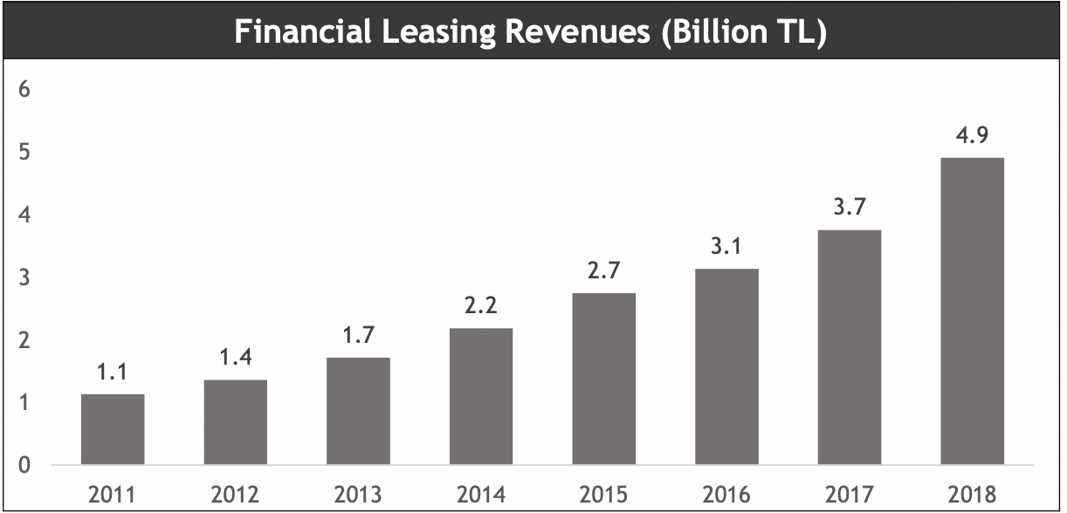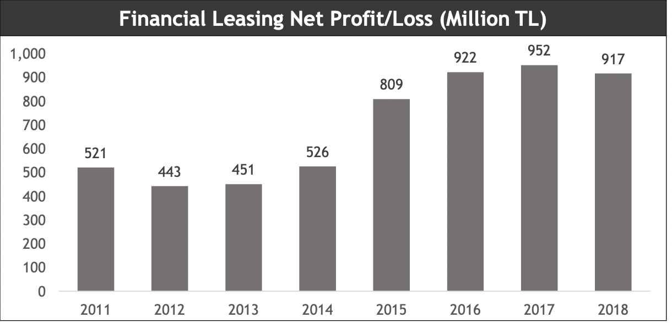

(Figures 3.1 and 3.2: from the report of the Republic of Türkiye Investment Office).

The leasing sector is followed by the Non-Metal industry. The non-mental industry has the second-best average return per risk. This might be caused by the correlation, see Sharp section of the report, between the construction sector and the non-metal industry. Due to the importance given to the construction sector given by government policies, the performance of companies that supply cement and stone might be positively affected by this situation. Nonmetal is closely followed by the textile sector which is one of the biggest and oldest sectors of Turkey. It is highly supported by government policies, as the government takes less value-added tax and tariffs on textile goods. Similar incentives and supports are valid for the chemical sector. Besides these, the Chemical and Textile industry supplies products to various domestic sectors and markets but also to foreign markets. When a domestic risky environment happens in the economy these sectors have the chance to minimize the effects by continuing to make sales to foreign markets. Hence protecting itself from the risks, and having better average returns per day of collapse.

The transportation and Tourism sectors stand out as sectors whose shares perform well and make good profits in the periods when domestic and international tourism activities and relations increase. Possible reasons for transportation ranking high on the table would be the logistic location of Turkey, and the investments made into airports and ports suitable for transit trade. As an example figure 3.3 shows how airlines companies proceeded towards the past 10 years. Tourism, on the other hand, is more prone to collapse as it is directly influenced by the macroeconomic fragility, political situation, and safeness of a country. The political events of the summer of 2016, the short-term political crisis with Russia, and the pandemic are all possible factors that negatively affect the tourist flows plus foreign tourist income. These unpredictable events cause fluctuations in the sector and cause poor performance during bad times. Although both sectors were negatively affected by the recent Covid-19 pandemic crisis, these sectors started to perform positively after the normalization of the conditions which indicates the ability of the sectors to bounce back. As a result, Tourism is placed lower on the table, however, it has little difference from other sectors that came better off.

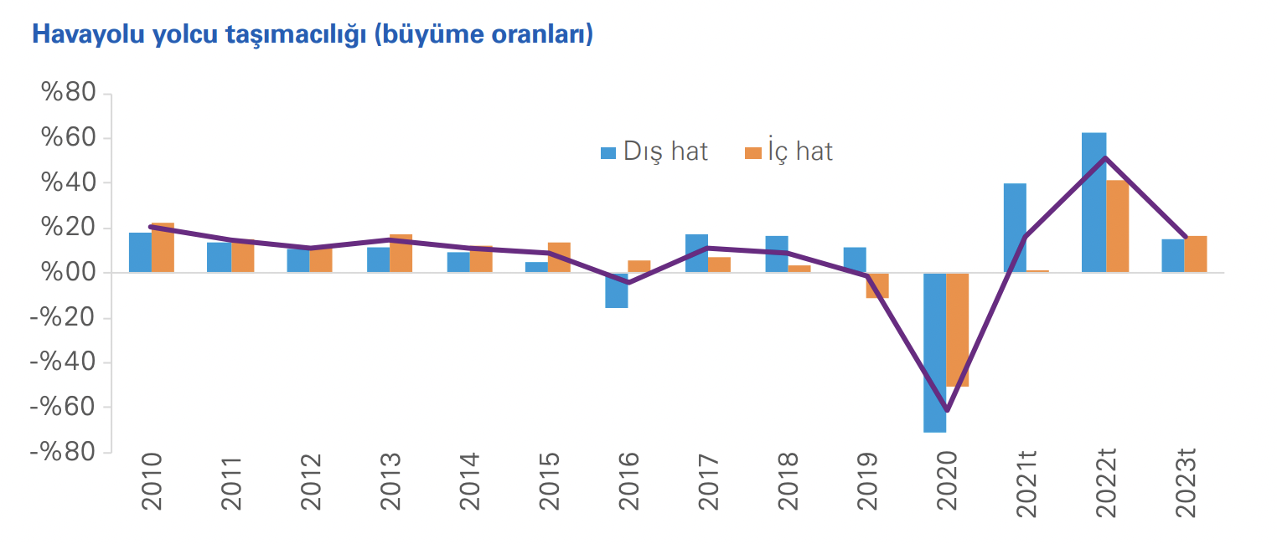

(Figure 3.3 from KPMG perspective report for transportation and logistic sectors.)

The banking sector is one of the sectors that have a lower ratio value, slightly off from the midtable. One of the reasons for this might be the regulations set by the Turkish Republic Central Bank. The Central Bank restricts the dividend payment of the banks resulting in less demand for stocks hence less return overall. In addition to this, the doubtful debts due to the loans given increase especially in times of economical crisis. This might result in banks performing poorly during an economical failure and having lower average returns per amount of collapses. For example, banks gave extensive loans to the construction sector and when the sector started to stagnate(over a period of time or in general) the debts returned as illiquid claims. Another example would be the banks having problems receiving the currency-based loans given to the energy sector because of the sudden increase in currency rates. Lastly, as it is stated before, the serious accusations and lawsuits against Halkbank played a role in the decrease in the overall performance of the sector, challenging the trust and reputation of it. Banking has a lower average return per collapse day so performs poorly.

Despite the demand for telecommunication services in Turkey, most specifically access to the internet and mobile phone, the telecom sector has the lowest ratio in Sharpe, Sortino, and Return to VaR. The general characteristics of the sector such as high dependency on foreign material and technology products for infrastructure and services plus the low capital accumulation to make investments might be possible reasons for overall relatively poor performance(“KPMG Sektörel Bakış Telekomünikasyon”, 2020). Also, the performance of Türk Telekom because of the change of ownership, poor management, and high debt to banks might affect the course of the industry. Since the control of Türk Telekom was taken by banks the sector is performing moderately well however all the fluctuations in the price index and poor performance during the crisis possibly caused the telecom industry to have the lowest average return per bad day.

**Calmar Ratio**

| **Industries** | **Calmar Ratio** |
| --- | --- |
| Industrial | 0.00940 |
| Chemicals | 0.00910 |
| Spor | 0.00884 |
| Telecommunication | 0.00868 |
| National Tech | 0.00864 |
| Basic Mats. | 0.00858 |
| Insurance | 0.00856 |
| Info Tech | 0.00848 |
| Transport | 0.00835 |
| Bank | 0.00820 |
| Retail & Trade | 0.00813 |
| Wood Paper & Print | 0.00788 |
| Food & Beverage | 0.00747 |
| Investment Trust | 0.00742 |
| Leasing | 0.00729 |
| Textile | 0.00725 |
| Holding | 0.00722 |
| Non-Metal | 0.00698 |
| National Financial | 0.00627 |
| Tourism | 0.00597 |
| Metal Goods & Machinery | 0.00564 |
| Electricity | 0.00446 |
| National Services | 0.00445 |

(Table 1.4: Calmar Ratios of Industries)

The table illustrates selected Turkish industries/sectors and their respective Calmar Ratio were calculated through daily Price Index values for approximately twenty-years. With respect to their Calmar Ratio it is noted that higher values signify that the performance of the index proposes a better performance on a risk-adjusted basis.(Kenton 2021) The Calmar Ratio is calculated through receiving average rate of return versus its maximum drawdown. The data collected above indicates the negative daily return for each index for a 20 year period is collected to calculate the max drawdown and then the average return is divided by the max-drawdown. The worst performing risk-adjusted sectors include; National SVS, Electricity, Metal Goods. MCH, and Tourism. Furthermore the highest risk-adjusted sector performances were observed to be INDLS, Chemicals, Sports and Telecoms.

The determining factors that lead to National SVS performing relatively worse could depend on development of technology regarding mobile-phones and diverting dynamics of receiving channel connection through the satellite. Hence the Price Index witnessed fluctuations and the Calmar Ratio indicates that the returns of the Price index performed worst with respect to their max drawdown values. However, the measurement also ignores volatility hence the occurred drawdowns can be related to high volatility at a given time period. Nevertheless, the electricity index is observed to be affected by foreign markets and even politics. Russia-Ukraine conflict impacted energy prices and military and security expenditures increased in the national economy. Hence overall production cost of electricity increased and the necessity of the product prevented relative losses on sales. Therefore, the retained earnings of equities in the industry led to gradual increases in the price index. As well as, perpetuous fluctuations are observed to be cunning, however the public offerings of the equities under the index increased during the last five year period. Majority of the new public offerings include Merger and Acquisition (M&A) to grant incentive towards using reusable energy through Solar panels, Hydro Water plants, and Wind energy. It is noted that Hydroelectric Power Plants were incentivized by the government and investments increased by 48% between 2001-2021. Hence leading to preventing USD 6.7 billion worth of electricity imports for the country (Şafak 2022). Hence, investors viewed the firm to have long-term results instead of witnessing instantaneous drawdowns that have a gradual risk. More interestingly, Year-to-day Price Index of the electricity market witnessed all-time increases on returns, which can lead to investors' psychological decisions leading to instant drawdowns, since Calmar Ratio does not account for positive returns.

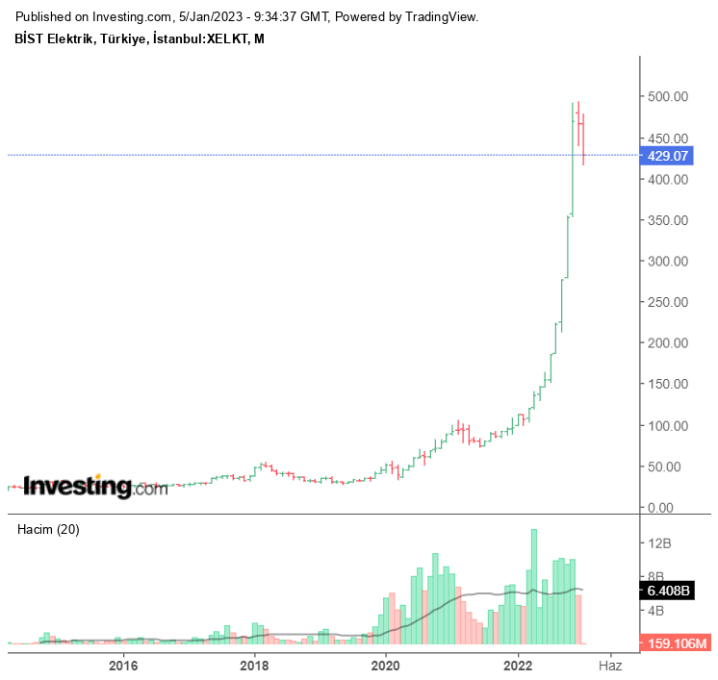

(Figure 4.1: XELKT values received from Investing.com)

Additionally, Tourism is another evident industry that performed relatively worst returns during a risk-adjusted basis. Despite Tourism being one of Turkey’s outstanding sectors, throughout the years it has witnessed both positive and negative effects. More concerningly, the COVID-19 epidemic resulted in hefty restrictions on traveling and tourism. Leading to severe continuous dropdowns. It is observed that during the period (Jan-Oct) 2020 foreign tourists that traveled to Turkey decreased by 72.5% compared to the previous year (GÜLER ÖZÇALIK and EREN 2022). The global crises immediately impacted the industry causing unexpected outcomes Hences is the definitive reason for the low performance of the risk-adjusted returns of the tourism industry. Furthermore, despite the depreciation of Turkish Lira and Turkey becoming more desirable to attract foreign tourists, the drastic increase in tourism was only witnessed after the restrictions preventing the spread of the COVID-19 epidemic were reduced. Therefore, the industry overall became less desirable for investors to purchase equities, since predictions of the outcome became more realistic for the investors.

On the other hand sectors like Sports are difficult for investors to predict outcome since the performance of the sports club reflects their future success and the fluctuations of its price index are extremely common. The reason behind it relates to the risk factors of the industry hence the returns made from the risks are extremely difficult to predict. Therefore the Calmar Ratio with regards to the returns for its price index reflected desirable outcomes. However, the risk factor compared to other industries is comparatively higher due to unmeasurable uncertainties.

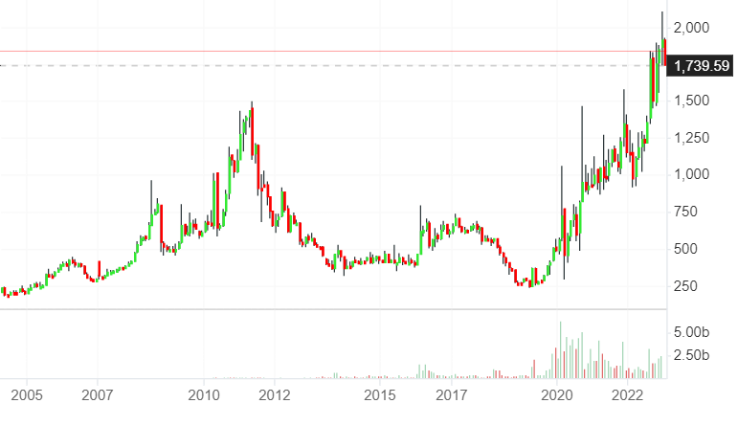

(Figure 4.2: Sport Industry Index received from Investing.com)

The Figure above indicates a broad understanding of the fluctuations and consistent drawdowns throughout the eighteen year period. The risks taken by the investors throughout constant graphic movements indicate a greater return or risk reward for the investor however as stated previously Calmar Ratio does not account for positive returns hence it evaluates the potential return benefit during risk adjustments.

Additionally, as mentioned previously for telecommunication Türk Telekom had extensive numbers of debt and the wealth fund was used to repurchase the shares. However, the ongoing volatility issues regarding Telecommunications and the adaptiveness of the innovation to daily-life were the reasons that left many investors to reconsider during the early stages of its public offerings. Moreover, when taking the near example of COVID-19 crisis, many individuals started to benefit from the advancements of telecommunications. Companies such as Turkcell, and Türk Telekom became more volatile. Since, the implementation of lockdown by the government regulation led individuals to reconsider their entertainment possibilities. Hence the time spent during quarantine actually increased viewing and adapted more use of telecommunications into people’s lifestyle. Ultimately, the impact of a mobile device became crucially important for an individuals lifestyle since the utility & functionality of the device developed through technology. Moreover, other indexes such as retail & trade, holdings, and leasing shared similar Calmar Ratios which potentially suggest that they have similar risk-adjusted returns since the industries have been growing gradually with comparatively less fluctuations.

Below we evaluated industries banking, chemicals, financial institutions and energy sector.

**PART.2: EQUITIES**

**BANKING SECTOR (Arda)**

Below tables show the risk measures that are calculated for XBANK.

| **Equity** | **Sharpe Ratio** |
| --- | --- |
| TÜRKİYE SINAI VE KALKINMA BANKASI. | 0.05217 |
| GARANTI | 0.04291 |
| YAPI VE KREDI BANKASI | 0.03488 |
| IS BANK 'C' | 0.03351 |
| AKBANK | 0.03114 |
| ICBC | 0.02583 |
| SEKERBANK | 0.02195 |
| VAKIFBANK | 0.01682 |
| ALBARAKA | 0.00906 |
| QNB | 0.00830 |
| HALKBANK | 0.00793 |
| TÜRKİYE KALKINMA VE YATIRIM BANKASI | 0.00353 |
| IS BANK 'B' | 0.00049 |
| IS BANK 'A' | -0.0282 |

(Table 5.1: Sharpe Rankings of Banking Sector)

| **Equity** | **Sortino Ratio** |
| --- | --- |
| IS BANK 'A' | 0.06238 |
| TÜRKİYE SINAI VE KALKINMA BANKASI. | 0.04581 |
| SEKERBANK | 0.03673 |
| GARANTI | 0.03359 |
| ICBC | 0.03035 |
| YAPI VE KREDI BANKASI | 0.03021 |
| AKBANK | 0.02955 |
| TÜRKİYE KALKINMA VE YATIRIM BANKASI | 0.02946 |
| IS BANK 'C' | 0.02903 |
| ALBARAKA | 0.02787 |
| QNB | 0.02567 |
| VAKIFBANK | 0.02457 |
| HALKBANK | 0.02235 |
| IS BANK 'B' | 0.01425 |

(Table 5.2: Sortino Rankings of Banking Sector)

| **Equity** | **Return to VaR** |
| --- | --- |
| IS BANK 'A' | 0.09202 |
| TÜRKİYE SINAI VE KALKINMA BANKASI. | 0.06498 |
| SEKERBANK | 0.04960 |
| GARANTI | 0.04837 |
| ICBC | 0.04458 |
| AKBANK | 0.04395 |
| YAPI VE KREDI BANKASI | 0.04325 |
| ALBARAKA | 0.04027 |
| TÜRKİYE KALKINMA VE YATIRIM BANKASI | 0.03926 |
| IS BANK 'C' | 0.03914 |
| VAKIFBANK | 0.03359 |
| QNB | 0.03323 |
| HALKBANK | 0.03248 |
| IS BANK 'B' | 0.01846 |

(Table 5.3: Value at Risk Rankings of Banking Sector)

| **Equity** | **Calmar** |
| --- | --- |
| TÜRKİYE SINAI VE KALKINMA BANKASI. | 0.00795 |
| GARANTI | 0.00718 |
| AKBANK | 0.00676 |
| IS BANK 'C' | 0.00654 |
| ICBC | 0.00644 |
| YAPI VE KREDI BANKASI | 0.00624 |
| SEKERBANK | 0.00473 |
| VAKIFBANK | 0.00403 |
| QNB | 0.00347 |
| ALBARAKA | 0.00317 |
| TÜRKİYE KALKINMA VE YATIRIM BANKASI | 0.00207 |
| HALKBANK | 0.00175 |
| IS BANK 'B' | 0.00144 |
| IS BANK 'A' | -9.40E-06 |

(Table 5.4: Calmar Rankings of Banking Sector)

As can be seen from the above tables, IS BANK ‘A’ and IS BANK ‘C’ have some strange behaviors which are caused by their different trading routines. While interpreting these tables these equities should be ignored. Aside from these, the best equity is TKI.SINAI KALK.BKSI or in other words “Türkiye Sınai Kalkınma Bankası”. After that if the tables are evaluated, in general Garanti has the second best performance. Worst behavior is, when above mentioned equities with initiative are ignored, clearly Halkbank. This was an expected result due to its ongoing trials.

**Chemicals Sector (Ahmet Can)**

| **Equity** | **Sharpe Ratio** |
| --- | --- |
| HEKTAS TICARET | 0.06781 |
| ALKIM | 0.05064 |
| AYGAZ | 0.04955 |
| GUBRE FABRIKALARI | 0.04885 |
| TUPRAS TKI.PEL.RFNE. | 0.04685 |
| SASA POLYESTER A | 0.04262 |
| BAGFAS BANDIRMA GUBRE | 0.04166 |
| AKSA | 0.04116 |
| EGE GUBRE SANAYI | 0.04080 |
| DEVA HOLDING | 0.03663 |
| BRISA BDGSN.SLK.SANVETC | 0.03449 |
| PETKIM PETROKIMYA HLDG | 0.02867 |
| BERKOSAN YALITIM VE TICARET LTD. | 0.02662 |
| SANIFOAM ENDI.VE TUKETIM URUNLERI SATT. | 0.02637 |
| GOODYEAR LASTIKLERI | 0.02495 |
| EGE PROFIL TIVSNY | 0.02286 |
| DYO BOYA FKI.SANVETC. | 0.01673 |
| MARSHALL BOYA | 0.01546 |
| EGEPLAST | 0.01122 |
| ACISELSAM ACI | 0.00538 |

(Table 6.1: Sharpe Rankings of Chemicals Sector)

| **Equity** | **Sortino Ratio** |
| --- | --- |
| BERKOSAN YALITIM VE TICARET LTD. | 0.06511 |
| HEKTAS TICARET | 0.04518 |
| AYGAZ | 0.03878 |
| SANIFOAM ENDI.VE TUKETIM URUNLERI SATT. | 0.038489 |
| GUBRE FABRIKALARI | 0.038488 |
| BRISA BDGSN.SLK.SANVETC | 0.03661 |
| SASA POLYESTER A | 0.03631 |
| ALKIM | 0.03606 |
| DEVA HOLDING | 0.03529 |
| EGE GUBRE SANAYI | 0.03437 |
| BAGFAS BANDIRMA GUBRE | 0.03381 |
| TUPRAS TKI.PEL.RFNE. | 0.03330 |
| AKSA | 0.03289 |
| EGE PROFIL TIVSNY | 0.03148 |
| GOODYEAR LASTIKLERI | 0.03143 |
| MARSHALL BOYA | 0.03123 |
| PETKIM PETROKIMYA HLDG | 0.02773 |
| DYO BOYA FKI.SANVETC. | 0.02537 |
| EGEPLAST | 0.02197 |
| ACISELSAM ACI | 0.00618 |

(Table 6.2: Sortino Rankings of Chemicals Sector)

| **Equity** | **Return to Value at Risk** |
| --- | --- |
| BERKOSAN YALITIM VE TICARET LTD. | 0.08751 |
| HEKTAS TICARET | 0.06650 |
| AYGAZ | 0.05714 |
| GUBRE FABRIKALARI | 0.05282 |
| SANIFOAM ENDI.VE TUKETIM URUNLERI SATT. | 0.05261 |
| ALKIM | 0.05218 |
| SASA POLYESTER A | 0.05023 |
| DEVA HOLDING | 0.04856 |
| BRISA BDGSN.SLK.SANVETC | 0.04769 |
| EGE GUBRE SANAYI | 0.04748 |
| TUPRAS TKI.PEL.RFNE. | 0.04724 |
| BAGFAS BANDIRMA GUBRE | 0.04646 |
| AKSA | 0.04619 |
| EGE PROFIL TIVSNY | 0.04542 |
| GOODYEAR LASTIKLERI | 0.04242 |
| MARSHALL BOYA | 0.04234 |
| PETKIM PETROKIMYA HLDG | 0.03720 |
| ACISELSAM ACI | 0.03652 |
| DYO BOYA FKI.SANVETC. | 0.03585 |
| EGEPLAST | 0.02822 |

(Table 6.3: Return to Value at Risk Rankings of Chemicals Sector)

| **Equity** | **Average Calmar** |
| --- | --- |
| HEKTAS TICARET | 0.01188 |
| GUBRE FABRIKALARI | 0.00945 |
| TUPRAS TKI.PEL.RFNE. | 0.00866 |
| ALKIM | 0.00843 |
| BAGFAS BANDIRMA GUBRE | 0.00824 |
| AKSA | 0.00810 |
| AYGAZ | 0.00761 |
| EGE GUBRE SANAYI | 0.00725 |
| SASA POLYESTER A | 0.00716 |
| DEVA HOLDING | 0.006730 |
| PETKIM PETROKIMYA HLDG | 0.006729 |
| BRISA BDGSN.SLK.SANVETC | 0.00625 |
| EGE PROFIL TIVSNY | 0.00552 |
| GOODYEAR LASTIKLERI | 0.00523 |
| MARSHALL BOYA | 0.00416 |
| DYO BOYA FKI.SANVETC. | 0.00393 |
| BERKOSAN YALITIM VE TICARET LTD. | 0.00374 |
| SANIFOAM ENDI.VE TUKETIM URUNLERI SATT. | 0.00351 |
| EGEPLAST | 0.00286 |
| ACISELSAM ACI | 0.00154 |

(Table 6.4: Calmar Rankings of Chemicals Sector)

In this respect; the average Sharpe Ratio for HEKTS is calculated as % 6,781; in other words, the return for HEKTS for the given time of period is % 6,781 over the risk free return, performing the best in the stocks listed in the table. Adversely; the risk-free return for ACSEL is % 0,538, the lowest among the stocks shown in the table.

Similar to the Sharpe Ratio, the Sortino Ratio also measures the “risk-adjusted return” of the stock/asset. The difference is that the Sortino Ratio takes into account the return in terms

of unit-risk. Eventually, the higher the Sortino Ratio is; the better the stock, asset or the portfolio is.In this respect; the average Sortino Ratio for BRKSN is calculated as % 6,511; in other words, the return for BRKSN for the given time of period is % 6,511 in terms of the unit risk (volatility) of the stock, performing the best in the stocks listed in the table.

The average Return to VaR of BRKSN is calculated as % 8,751, i.e. the average return per bad days of BRKSN stock is % 8,751; compared to EPLAS with % 2,822 Return to VaR value, approximately 3 times performs better during riskier times.

Similar to the Sharpe and Sortino Ratio, the Calmar Ratio also measures the “risk-adjusted return”. The difference is that the CalmarRatio takes into account the maximum drawdown or the highest drop in the price. The higher theCalmar ratio is, the more preferred the portfolio is. In this respect; the average Calmar Ratio for HEKTS is calculated as % 1,188; in other words, the risk-adjusted return for HEKTS for the given time of period is % 1,188 compared to the highest drop in the price, performing the best in the stocks listed in the table.

**Financial Institutions (Batu)**

| **Equities** | **Sharpe** |
| --- | --- |
| İŞ YATIRIM ORTAKLIĞI A.Ş. | 0.06156 |
| TÜRKİYE ŞİŞE VE CAM FABRİKALARI A.Ş. | 0.05589 |
| ECZACIBAŞI YATIRIM HOLDİNG ORTAKLIĞI A.Ş. | 0.05581 |
| GARANTİ FAKTORİNG A.Ş. | 0.05274 |
| EİS ECZACIBAŞI İLAÇ SINAİ VE FİNANSAL YATIRIMLAR SANAYİ VE TİCARET A.Ş. | 0.04784 |
| AKSİGORTA A.Ş. | 0.04737 |
| ANADOLU ANONİM TÜRK SİGORTA ŞİRKETİ | 0.04732 |
| DAGİ YATIRIM HOLDING A.Ş. | 0.04617 |
| KOÇ HOLDING A.Ş. | 0.04176 |
| ALARKO HOLDİNG A.Ş. | 0.04165 |
| DOĞAN ŞİRKETLER GRUBU HOLDİNG A.Ş. | 0.03770 |
| GLOBAL HOLDİNG YATIRIM A.Ş. | 0.03575 |
| TÜRKİYE SİGORTA A.Ş. | 0.03388 |
| NET HOLDİNG A.Ş. | 0.03255 |
| ÖZDERİCİ GAYRİMENKUL YATIRIM ORTAKLIĞI A.Ş. | 0.03244 |
| ATLAS MENKUL KIYMETLER YATIRIM ORTAKLIĞI A.Ş. | 0.03124 |
| VAKIF MENKUL KIYMET YATIRIM ORTAKLIĞI A.Ş. | 0.02753 |
| VAKIF FİNANSAL KİRALAMA A.Ş. | 0.02316 |
| PERA GAYRİMENKUL YATIRIM ORTAKLIĞI A.Ş. | 0.01476 |
| AVRASYA GAYRİMENKUL YATIRIM ORTAKLIĞI A.Ş. | 0.00800 |

(Table 7.1: Sharpe Rankings of Financial Institutions Sector)

| **Equities** | **Sortino** |
| --- | --- |
| ANADOLU ANONİM TÜRK SİGORTA ŞİRKETİ | 0.05274 |
| İŞ YATIRIM ORTAKLIĞI A.Ş. | 0.04753 |
| GARANTİ FAKTORİNG A.Ş. | 0.04616 |
| ECZACIBAŞI YATIRIM HOLDİNG ORTAKLIĞI A.Ş. | 0.03843 |
| DOĞAN ŞİRKETLER GRUBU HOLDİNG A.Ş. | 0.03784 |
| TÜRKİYE ŞİŞE VE CAM FABRİKALARI A.Ş. | 0.03758 |
| VAKIF FİNANSAL KİRALAMA A.Ş. A.Ş. | 0.03705 |
| ALARKO HOLDİNG A.Ş. | 0.03549 |
| TÜRKİYE SİGORTA A.Ş. | 0.03406 |
| DAGİ YATIRIM HOLDİNG A.Ş. | 0.03371 |
| AKSİGORTA A.Ş. | 0.03357 |
| ATLAS MENKUL KIYMETLER YATIRIM ORTAKLIĞI A.Ş. | 0.03337 |
| NET HOLDING A.Ş. | 0.03274 |
| GLOBAL HOLDING YATIRIM A.Ş. | 0.03223 |
| ÖZDERİCİ GAYRİMENKUL YATIRIM ORTAKLIĞI A.Ş. | 0.03207 |
| EİS ECZACIBAŞI İLAÇ SINAİ VE FİNANSAL YATIRIMLAR SANAYI VE TICARET A.Ş. | 0.03200 |
| VAKIF MENKUL KIYMET YATIRIM ORTAKLIĞI A.Ş. | 0.03024 |
| KOÇ HOLDİNG A.Ş. | 0.02870 |
| AVRASYA GAYRİMENKUL YATIRIM ORTAKLIĞI A.Ş. | 0.02459 |
| PERA GAYRİMENKUL YATIRIM ORTAKLIĞI A.Ş. | 0.02187 |

(Table 7.2: Sortino Rankings of Financial Institutions Sector)

| **Equities** | **Return to Value at Risk** |
| --- | --- |
| TÜRKİYE ŞİŞE VE CAM FABRİKALARI A.Ş. | 0.16565 |
| ANADOLU ANONIM TÜRK SIGORTA ŞİRKETI | 0.14342 |
| ECZACIBAŞI YATIRIM HOLDİNG ORTAKLIĞI A.Ş. | 0.13590 |
| TÜRKİYE SİGORTA A.Ş. | 0.12838 |
| ALARKO HOLDING A.Ş. | 0.12568 |
| VAKIF MENKUL KIYMET YATIRIM ORTAKLIĞI A.Ş. | 0.08944 |
| KOÇ HOLDİNG A.Ş. | 0.08754 |
| VAKIF FİNANSAL KİRALAMA A.Ş. | 0.07237 |
| EİS ECZACIBAŞI İLAÇ SINAİ VE FİNANSAL YATIRIMLAR SANAYI VE TICARET A.Ş. | 0.07087 |
| GARANTİ FAKTORİNG A.Ş. | 0.06360 |
| AKSİGORTA A.Ş. | 0.05945 |
| DOĞAN ŞİRKETLER GRUBU HOLDİNG A.Ş. | 0.05766 |
| PERA GAYRİMENKUL YATIRIM ORTAKLIĞI A.Ş. | 0.05421 |
| İŞ YATIRIM ORTAKLIĞI A.Ş. | 0.04935 |
| ATLAS MENKUL KIYMETLER YATIRIM ORTAKLIĞI A.Ş. | 0.04742 |
| GLOBAL HOLDING YATIRIM A.Ş. | 0.04690 |
| DAGİ YATIRIM HOLDİNG A.Ş. | 0.04627 |
| ÖZDERİCİ GAYRİMENKUL YATIRIM ORTAKLIĞI A.Ş. | 0.04540 |
| NET HOLDİNG A.Ş. | 0.04155 |
| AVRASYA GAYRİMENKUL YATIRIM ORTAKLIĞI A.Ş. | 0.03212 |

(Table 7.3: Return to Value at Risk Rankings of Financial Institutions Sector)

| **Equities** | **Calmar** |
| --- | --- |
| İŞ YATIRIM ORTAKLIĞI A.Ş. | 0.00983 |
| TÜRKİYE ŞİŞE VE CAM FABRİKALARI A.Ş. | 0.00946 |
| GARANTİ FAKTORİNG A.Ş. | 0.00891 |
| ECZACIBAŞI YATIRIM HOLDİNG ORTAKLIĞI A.Ş. | 0.00883 |
| DOĞAN ŞİRKETLER GRUBU HOLDİNG A.Ş. | 0.00857 |
| EİS ECZACIBAŞI İLAÇ SINAİ VE FİNANSAL YATIRIMLAR SANAYI VE TICARET A.Ş. | 0.00829 |
| AKSİGORTA A.Ş. | 0.00805 |
| TÜRKİYE SİGORTA A.Ş. | 0.00774 |
| GLOBAL HOLDİNG YATIRIM A.Ş. | 0.00770 |
| NET HOLDİNG A.Ş. | 0.00768 |
| ALARKO HOLDİNG A.Ş. | 0.00763 |
| ANADOLU ANONİM TÜRK SİGORTA ŞİRKETİ | 0.00755 |
| DAGİ YATIRIM HOLDİNG A.Ş. | 0.00683 |
| VAKIF FİNANSAL KİRALAMA A.Ş. | 0.00615 |
| KOÇ HOLDİNG A.Ş. | 0.00592 |
| ATLAS MENKUL KIYMETLER YATIRIM ORTAKLIĞI A.Ş. | 0.00572 |
| VAKIF MENKUL KIYMET YATIRIM ORTAKLIĞI A.Ş. | 0.00526 |
| ÖZDERİCİ GAYRİMENKUL YATIRIM ORTAKLIĞI A.Ş. | 0.00361 |
| PERA GAYRİMENKUL YATIRIM ORTAKLIĞI A.Ş. | 0.00299 |
| AVRASYA GAYRİMENKUL YATIRIM ORTAKLIĞI A.Ş. | 0.00234 |

(Table 7.4: Calmar Rankings of Financial Institutions Sector)

The tables given above are the ranking or the Sharpe, Sortino, return to value at risk and Calmar ratios of 20 firms from the Financial Institutions (XUMAL) index on the BIST100 index. By looking at these tables we can infer that Avrasya Gayrimenkul Yatırım Ortaklığı and Pera Gayrimenkul Yatırım Ortaklığı are not very good firms to invest in since they are towards the bottom. The best firms to invest in are İş Yatırım Ortaklığı, Türkiye Şişe ve Cam Fabrikaları and Eczacıbaşı Yatırım Holding Ortaklığı since they are towards the top in each of the tables.

**Energy Sector (Can)**

| **Equities** | **Sharpe Ratio** |
| --- | --- |
| SMRT.GUNES ENERJISI TEKNOLOJILERI ARASTIRMA | 0.27267 |
| CAN2 TERMIK AS | 0.17122 |
| NATUREL ENERJI | 0.10756 |
| BIOTREND CEVRE & ENERJI YATIRIMLARI | 0.09013 |
| MARGUN ENERJI URETIM SANAYI & TICARET | 0.08982 |
| KARTAL YENILENEBILIR ENJ.URM | 0.05341 |
| AYEN ENERJI | 0.04440 |
| AYDEM YENILENEBILIR ENERJI A S | 0.04140 |
| AKSU ENERJI VE TICARET | 0.03996 |
| GALATA WIND ENERJI | 0.03662 |
| ENERJISA ENERJI | 0.03635 |
| NATURELGAZ SANAYI VE TICARET | 0.03560 |
| ESENBOGA ELEKTRIK URETIM AS | 0.03407 |
| AKSA ENERJI URETIM | 0.02944 |
| ODAS ELEKTRIK B | 0.02663 |
| ZORLU ENERJI | 0.01820 |
| AKENERJI ELEKTRIK URETIM | 0.00983 |
| PAMEL YENILENEBILIR ELEKTRIK URETIM A S | -0.08298 |

(Table 8.1: Sharpe Rankings of Energy Sector)

| **Equities** | **Sortino Ratio** |
| --- | --- |
| SMRT.GUNES ENERJISI TEKNOLOJILERI ARASTIRMA | 0.14678 |
| CAN2 TERMIK AS | 0.11417 |
| BIOTREND CEVRE & ENERJI YATIRIMLARI | 0.08593 |
| MARGUN ENERJI URETIM SANAYI & TICARET | 0.07653 |
| NATUREL ENERJI | 0.06163 |
| NATURELGAZ SANAYI VE TICARET | 0.05691 |
| GALATA WIND ENERJI | 0.04518 |
| KARTAL YENILENEBILIR ENJ.URM | 0.04308 |
| ODAS ELEKTRIK B | 0.03917 |
| AYEN ENERJI | 0.03796 |
| AKSU ENERJI VE TICARET | 0.03738 |
| ESENBOGA ELEKTRIK URETIM AS | 0.03529 |
| ENERJISA ENERJI | 0.03202 |
| AYDEM YENILENEBILIR ENERJI A S | 0.03112 |
| AKSA ENERJI URETIM | 0.02904 |
| ZORLU ENERJI | 0.02775 |
| AKENERJI ELEKTRIK URETIM | 0.02287 |
| PAMEL YENILENEBILIR ELEKTRIK URETIM A S | -0.00776 |

(Table 8.2: Sortino Rankings of Energy Sector)

| **Equity** | **Avg. Return to VaR** |
| --- | --- |
| SMRT.GUNES ENERJISI TEKNOLOJILERI ARASTIRMA | 0.21390 |
| CAN2 TERMIK AS | 0.16461 |
| MARGUN ENERJI URETIM SANAYI & TICARET | 0.12337 |
| BIOTREND CEVRE & ENERJI YATIRIMLARI | 0.11993 |
| NATURELGAZ SANAYI VE TICARET | 0.09342 |
| NATUREL ENERJI | 0.08617 |
| GALATA WIND ENERJI | 0.06813 |
| ODAS ELEKTRIK B | 0.05673 |
| AYEN ENERJI | 0.05254 |
| AKSU ENERJI VE TICARET | 0.05240 |
| KARTAL YENILENEBILIR ENJ.URM | 0.05233 |
| AYDEM YENILENEBILIR ENERJI A S | 0.04946 |
| ESENBOGA ELEKTRIK URETIM AS | 0.04905 |
| ENERJISA ENERJI | 0.04656 |
| ZORLU ENERJI - TOT RETURN IND | 0.04478 |
| AKSA ENERJI URETIM | 0.04029 |
| AKENERJI ELEKTRIK URETIM | 0.03023 |
| PAMEL YENILENEBILIR ELEKTRIK URETIM A S | -0.02264 |

(Table 8.3: Return to Value at Risk Rankings of Energy Sector)

| **Equity** | **Avg. Calmar Ratio** |
| --- | --- |
| SMRT.GUNES ENERJISI TEKNOLOJILERI ARASTIRMA | 0.06137 |
| MARGUN ENERJI URETIM SANAYI & TICARET | 0.02244 |
| CAN2 TERMIK AS | 0.02095 |
| BIOTREND CEVRE & ENERJI YATIRIMLARI | 0.01879 |
| NATURELGAZ SANAYI VE TICARET | 0.01263 |
| NATUREL ENERJI | 0.01178 |
| KARTAL YENILENEBILIR ENJ.URM | 0.01098 |
| GALATA WIND ENERJI | 0.00893 |
| AKSU ENERJI VE TICARET | 0.00765 |
| ESENBOGA ELEKTRIK URETIM AS | 0.00724 |
| AYEN ENERJI | 0.00649 |
| AYDEM YENILENEBILIR ENERJI A S | 0.00620 |
| AKSA ENERJI URETIM | 0.00472 |
| ZORLU ENERJI - TOT RETURN IND | 0.00409 |
| AKENERJI ELEKTRIK URETIM | 0.00355 |
| ODAS ELEKTRIK B | 0.00353 |
| ENERJISA ENERJI | 0.00021 |
| PAMEL YENILENEBILIR ELEKTRIK URETIM A S | -0.01165 |

(Table 8.4: Calmar Rankings of Energy Sector)

The tables presented above consist of equities in the Energy sector. More importantly the public offering date of each equity may differ resulting in the equity experiencing different circumstances. For instance SMRT.GUNES ENERJISI TEKNOLOJILERI ARASTIRMA made its public offering on 24.03.2022 and the firm’s price index was not affected by earlier pandemic conditions hence resulting in higher ratio values. Since the measurement of each ratio was taken from the average of daily returns. Whereas the sector received lower values during the 2018-2019 period that affected an older firm’s average return. Nevertheless, the equities that were found to bring higher returns include; SMRT.GUNES ENERJISI TEKNOLOJILERI ARASTIRMA, MARGUN ENERJİ, and CAN2 Termik. All three of these equities made their public offerings within a span of two years.

**Conclusion & Discussion**

Our analysis supports the claim that an industry's performance on one risk metric is generally indicative of its performance on other risk metrics. For instance, if the textile industry performs well in Sharpe it probably has a good Sortino Ratio. Specifically, we found that industries that performed well on one risk metric tended to also perform well on the others, while industries that performed poorly on one risk metric tended to also perform poorly on the others. This finding is important because it suggests that practitioners can use a single risk metric as a reliable indicator of overall risk performance. However, it is important to note that this relationship is not perfect, and there may be some exceptions where an industry's performance on one risk metric does not accurately reflect its performance on others.

Another point is that an industry supported by the government tends to perform well according to risk metrics. We found that industries with government support consistently ranked highly on various risk metrics, namely Sharpe, Sortino, Calmar and value at risk. This might show both government support can be an important factor in reducing risk or improving overall performance. Even though the relationship is not absolute and there may be some exceptions where an industry with government support does not perform as well as expected; probability of a similar performance is high.

Since the above mentioned situations are observed using the BIST industries, to make a generalization about worldwide situations an overarching research is needed. Even though there is a clear need for general research, the results show more than just correlation; it also has strong causes to claim that. Because governments are trusted and have capabilities to allocate taxes and conduct great amounts of money, compared to corporations, their help would reduce risk and increase the returns. Further research is needed to explore these exceptions and to better understand the underlying factors that contribute to the observed relationship between government support and risk adjusted performance.

**References:**

Bayrak İ. C. & Telatar O. M. (2021). İnşaat sektörü ve ekonomik büyüme ilişkisi: Türkiye ekonomisi üzerine ampirik bir analiz. Gümüşhane Üniversitesi Sosyal Bilimler Enstitüsü Elektronik Dergisi, 12(3), 1283-1297.

foreks.com. (07, October 2022). Anadolu Isuzu, "Yatırım Teşvik Belgesi" aldı.<https://foreks.com/haber/detay/633f9bee4cedfd0001315d93/PICNEWS/tr/anadolu-isuzu-yatirim-tesvik-belgesi-aldi>

Fusion Media Limited. n.d. “BIST Electricity Grafiği - Investing.com.” Investing.com Türkiye. Accessed January 5, 2023. <https://tr.investing.com/indices/ise-electricity-chart>.

GÜLER ÖZÇALIK, Sevinç, and Binali Selman EREN. 2022. “COVID-19 (Koronavirüs) Pandemisinin Turizm Endeksleri Üzerindeki Etkisi: Bir Olay Çalışması.” *Celal Bayar Üniversitesi Sosyal Bilimler Dergisi*, March, 136–50. <https://doi.org/10.18026/cbayarsos.1015859>.

Hürriyet.com. (09, April 2018). İşte 'Süper Teşvik'ten yararlanacak o firmalar.<https://www.hurriyet.com.tr/ekonomi/iste-super-tesvikten-yararlanacak-o-firmalar-40799307>

Kenton, Will. 2021. “Calmar Ratio.” Investopedia. May 21, 2021. <https://www.investopedia.com/terms/c/calmarratio.asp>.

KPMG Perspektifinden Taşımacılık ve Lojistik Sektörüne bakış (2021). Retrieved from <https://home.kpmg/tr/tr/home/gorusler/2021/09/kpmg-perspektifinden-tasimacilik-ve-lojistik-sektorune-bakis-2021.html>

Ozan Kose. (05, May 2021). Halkbank davasıyla ilgili neler biliniyor? Euronews.<https://tr.euronews.com/2021/05/03/3-may-s-ta-baslamas-beklenen-halkbank-davas-yla-ilgili-neler-biliniyor>

Özel İhtisas Komisyonu. (2008). *Dokuzuncu Kalkınma Planı: Taş ve Toprağa Dayalı Sanayiler Cilt 1*

Plus Global Danışmanlık. (2020). Tekstil Sektörü Teşvik ve Destekleri [Press Release].<https://www.plusglobal.com.tr/tekstil-sektoru-tesvik-ve-destekleri>

Republic of Turkey Ministry of Trade (2022). CHEMICAL INDUSTRY IN TÜRKİYE.

Residency of the Republic of Türkiye Investment Office (2021). Automotive.<https://www.invest.gov.tr/en/sectors/pages/automotive.aspx>

Robiyanto, R. (2017).PERFORMANCE EVALUATION AND RISK AVERSION RATE FOR SEVERAL STOCK INDICES IN INDONESIA STOCK EXCHANGE. Jurnal Manajemen dan Kewirausahaan, 19(1), 60-64. DOI: 10.9744/jmk.19.1.60–64.

Simons K. (1998). Risk-Adjusted Performance of Mutual Funds. New England Economic Review. issue Sep, 33-48.

Şafak, Yeni. 2022. “Bir Yılda Hidroelektrik Yüzde 48 Arttı.” Yeni Şafak. April 25, 2022. <https://www.yenisafak.com/ekonomi/bir-yilda-hidroelektrik-yuzde-48-artti-3806796#:~:text=T%C3%BCrkiye%27nin%20hidroelektrik%20enerji%20kurulu>.

Şişman, D. & Şişman, M. (2017). LEASING AND IMPORTANCE TO ECONOMY: SOME RISKS, ADVANTAGES . Journal of Management and Economics Research , Cilt: 15 Sayı: Özel Sayı 1 , 144-154 . DOI: 10.11611/yead.373453

Tandon, N., Reddy, E, E.(July, 2013). A STUDY ON EMERGING TRENDS IN TEXTILE INDUSTRY IN INDIA. International Journal of Advancements in Research & Technology, 2(7). 267-276. ISSN 2278-7763

TRTSpor. (2022, October 11). Dört büyükler borç batağında. <https://www.trtspor.com.tr/haber/futbol/spor-toto-super-lig/dort-buyukler-borc-bataginda-263277.html>

uzmanpara.milliyet.com.tr. (07, October 2021). Karsan'ın 240,8 milyon TL bedelli "Yatırım Teşvik Belgesi" başvurusu onaylandı.<https://uzmanpara.milliyet.com.tr/kap-haberi/karsanin-240-8-milyon-tl-bedelli-yatirim-tesvik-belgesi-basvurusu-onaylandi/2142633/>

Wang, Y. (2021, August 4). Analysis of Risks and Strategies of Investment in Global Sports Industry. Advances in Economics, Business and Management Research, 185. 216-221.<https://doi.org/10.2991/aebmr.k.210803.030>

Yeniçağ. (2021, December 17). *Devlet 3 bankayı Kurtarmak için türk telekom'u Satın Alıyor. Türkiye Cumhuriyeti'ni Soyup Kaçan oger'in Bıraktığı Enkaz*. Yeni Çağ Gazetesi. Retrieved January 5, 2023, from https://www.yenicaggazetesi.com.tr/devlet-3-bankayi-kurtarmak-icin-turk-telekomu-satin-aliyor-turkiye-cumhuriyetini-soyup-kacan-ogerin-biraktigi-enkaz-oysa-2026da-borcsuz-olarak-devlete-gececekti-zaten-493685h.html

Yeşil Ekonomi. (2020, December 4). Ford Otosan için süper teşvik kararı yayınlandı.<https://yesilekonomi.com/ford-otosan-icin-super-tesvik-karari-yayinlandi/>